**Title:** Linux Practical Task

**Name:** Gururaj Khule **Date:** 29-09-2025

**Task 1: Creating and Renaming Files/Directories**

* mkdir test_dir → Creates a new directory named test_dir.
* cd test_dir → Moves into the newly created directory.
* touch example.txt → Creates an empty file named example.txt.
* mv example.txt renamed_example.txt → Renames example.txt to

renamed_example.txt.

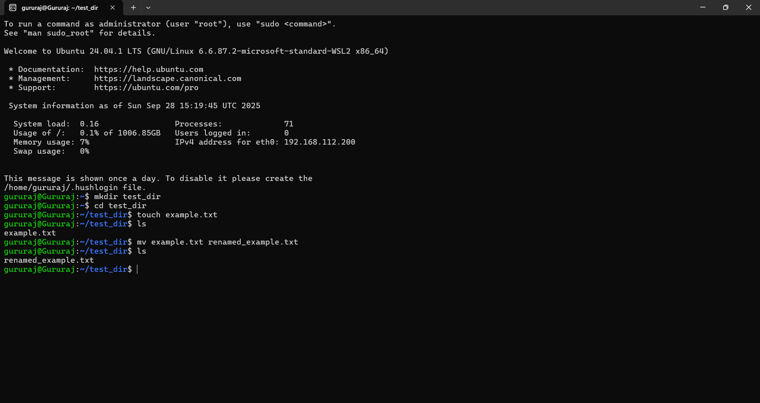

**Explanation:** This task demonstrates basic file and directory management in Linux — how to create directories, create empty files, and rename files.

**Task 2: Viewing File Contents**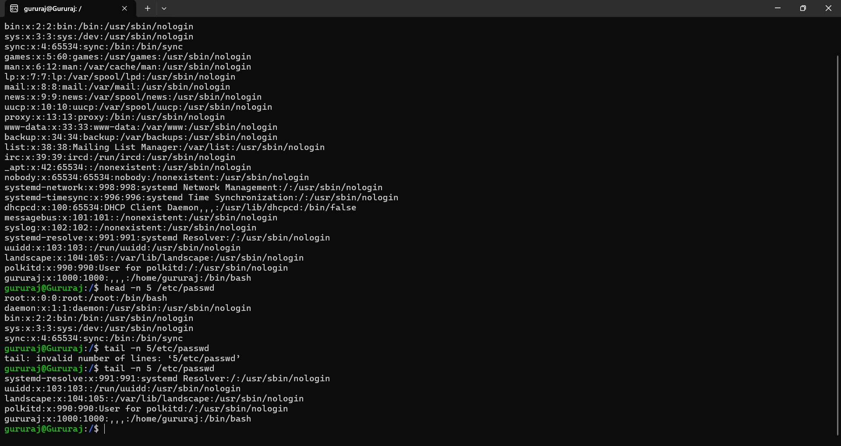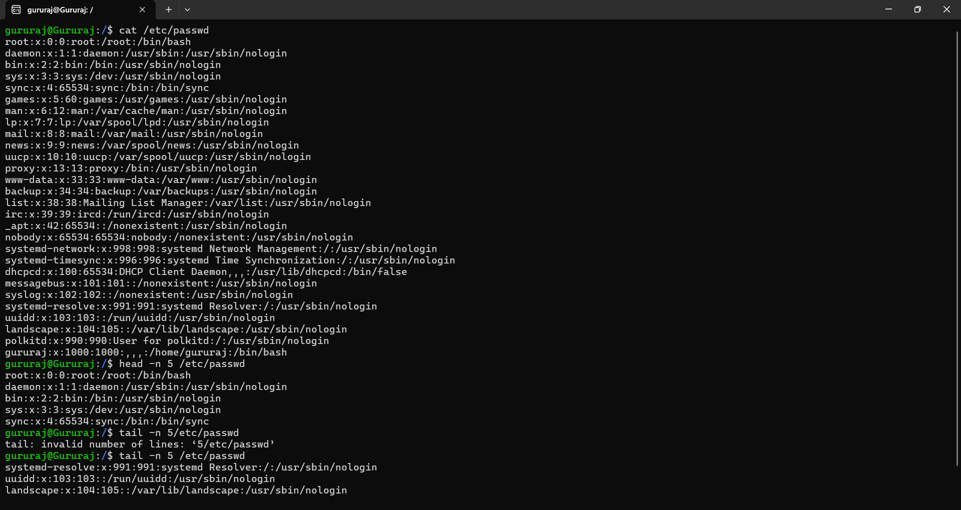

* cat /etc/passwd → Displays the entire content of the file.
* head -n 5 /etc/passwd → Shows the first 5 lines.
* tail -n 5 /etc/passwd → Shows the last 5 lines.

**Explanation:** This task shows how to view the contents of files. The /etc/passwd file contains information about system users, and commands like cat, head, and tail help read its contents in different ways**.**

**Task 3: Searching for Patterns**

* grep "root" /etc/passwd

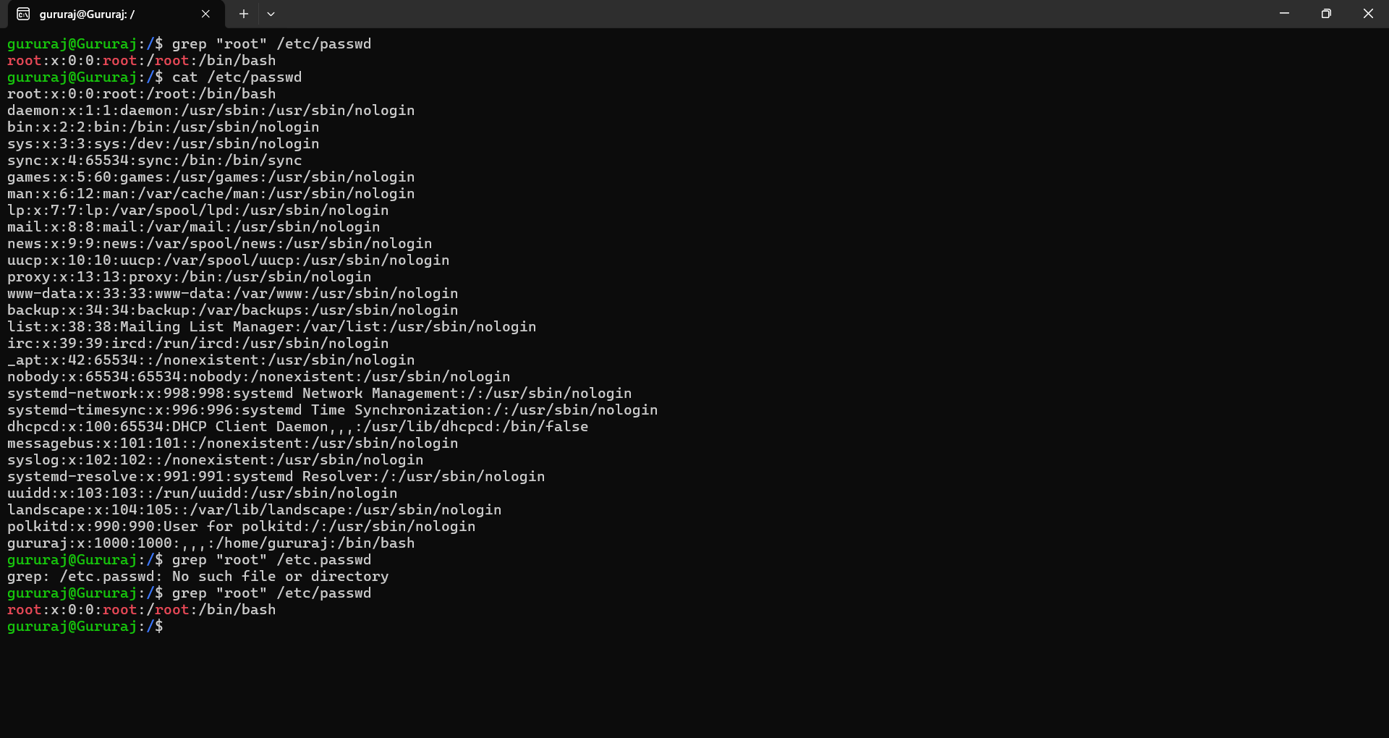

**Explanation:** grep searches for a specific word or pattern in a file. Here, it finds all lines containing “root” in /etc/passwd. The output line shows details about the root user (system administrator account).

**Task 4: Zipping and Unzipping**

* zip -r test_dir.zip test_dir → Compresses the directory test_dir into a zip file.
* mkdir unzipped_dir → Creates a new directory.
* unzip test_dir.zip -d unzipped_dir → Extracts contents of test_dir.zip into unzipped_dir

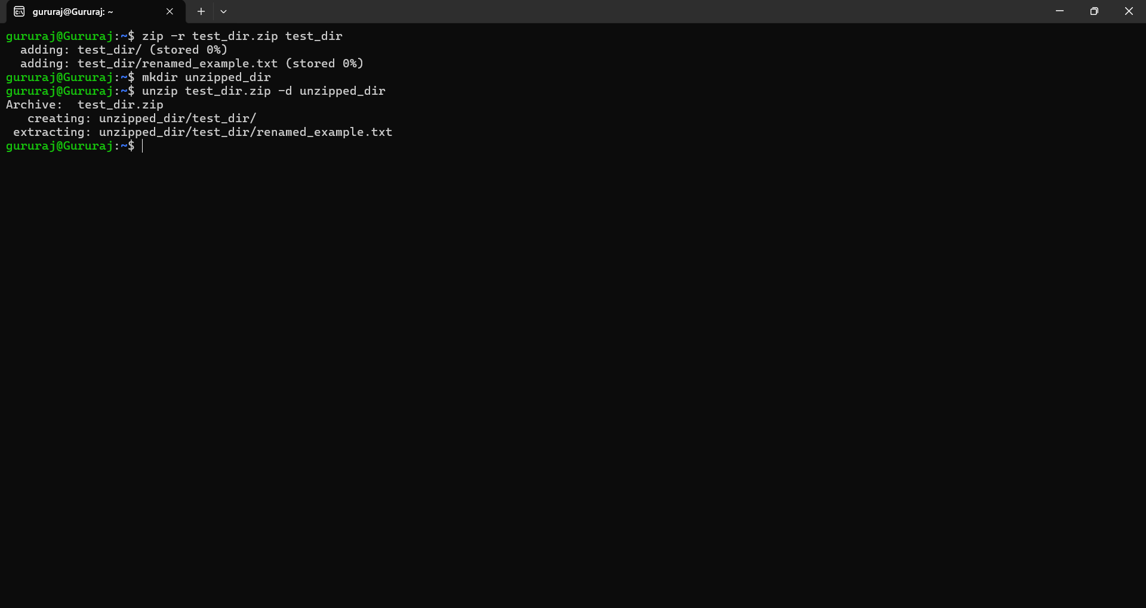

**Explanation:** This task demonstrates how to compress files/directories into .zip format and how to extract them. Compression saves space and makes it easier to transfer files.

**Task 5: Downloading Files**

* wget<URL>(e.g.,wgethttps://www.learningcontainer.com/wp-content/uploads/2020/04/sample-text-file.txt)

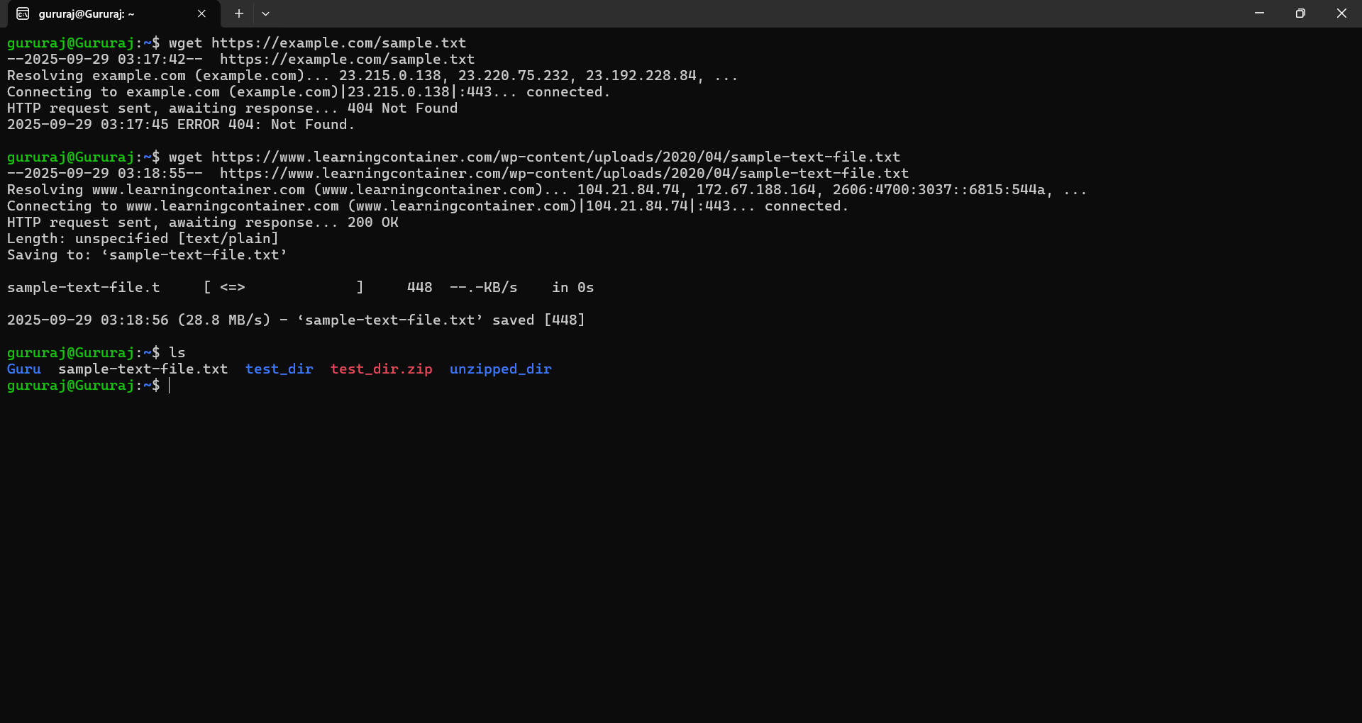

**Explanation:** wget is used to download files from the internet. When you give it a valid URL, it fetches the file and saves it in your current directory.

**Task 6: Changing Permissions**

* touch secure.txt → Creates a file.
* chmod 444 secure.txt → Changes permissions to read-only for everyone (owner, group, and others).

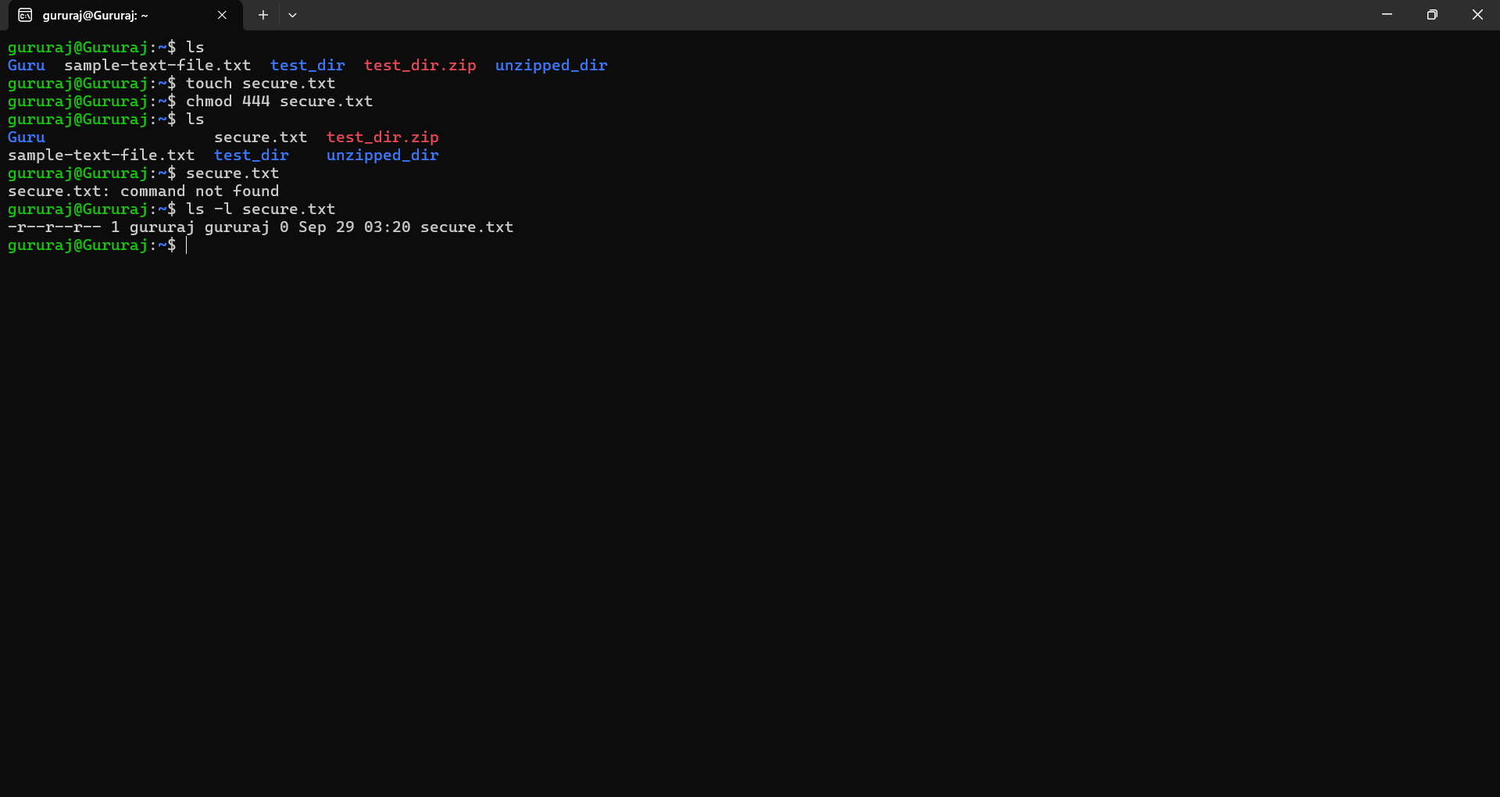

**Explanation:**

chmod modifies file permissions. With 444, the file becomes read-only, meaning no one can modify or delete its contents directly. This is useful for protecting important files.

### 

### 

### 

### 

### 

### 

### 

### **Task 7: Working with Environment Variables**

* export MY_VAR="Hello, Linux!" → Creates a new environment variable.
* echo $MY_VAR → Displays the value of the variable.

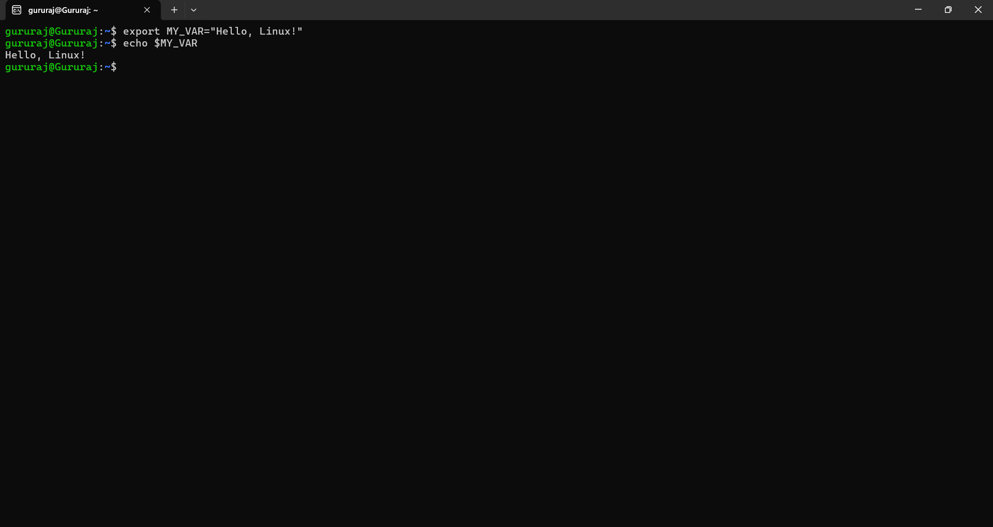

**Explanation:**

Environment variables are temporary values stored in memory that programs can use. Here, MY_VAR is set with the text “Hello, Linux!”, and echo confirms it is stored correctly.